BIT 4107 – Mobile Application Development
STUDENT PROJECT LOGBOOK
Project: SpareDash – Spare Parts Delivery and Management App

Student Name: | NEWTON KARIITHI
Admission Number: | BIT/2025/31318
School / Faculty: | SCHOOL OF COMPUTING AND INFORMATICS
Programme: | BACHELOR OF SSCIENCE IN IFORMATION TECHNOLOGY (BS IT)
Academic Year: | 2025/ 2026
Semester: | May/august
Lecturer: | MR MICHAEL NYORO
Phone Number: | 0790570950

Development Platform: Android Studio Language: Kotlin Year: 2026

INSTRUCTIONS
This logbook documents all weekly practical activities undertaken during the development of SpareDash, a native Android mobile application for spare parts delivery and management.

General Rules:
- Complete all sections every week without fail.
- Replace every screenshot placeholder with your actual screenshot from your device or screen.
- Personal reflections must not exceed 50 words.
- This logbook must be submitted together with your final project.
- AI-generated content without practical evidence and screenshots will not be accepted.
- All screenshots must be from your own machine, emulator, or connected Android device.

Note on Device Testing:
SpareDash is developed and tested using a real Android device connected via USB cable. USB Debugging must be enabled on the device. Screenshots should be taken from the device screen directly or using Android Studio screen capture.

WEEK 1: Introduction to Mobile Application Development

Practical Activities Undertaken
- Downloaded and installed Android Studio (latest stable version) on development machine.
- Completed Android Studio initial setup wizard including SDK download.
- Installed Android SDK: API 24 (minimum) and API 34 (target).
- Enabled Developer Options on Android phone by tapping Build Number 7 times.
- Enabled USB Debugging on Android phone under Developer Options.
- Connected Android phone to laptop via USB cable and confirmed device detected in Android Studio.
- Studied the mobile application ecosystem: Android vs iOS vs Cross-platform development.
- Installed Git and configured username and email for version control.
- Created GitHub account and repository named SpareDash.

Screenshots / Evidence
Screenshots Attached: Yes / No (circle one)

Screenshot: Android Studio installation complete screen
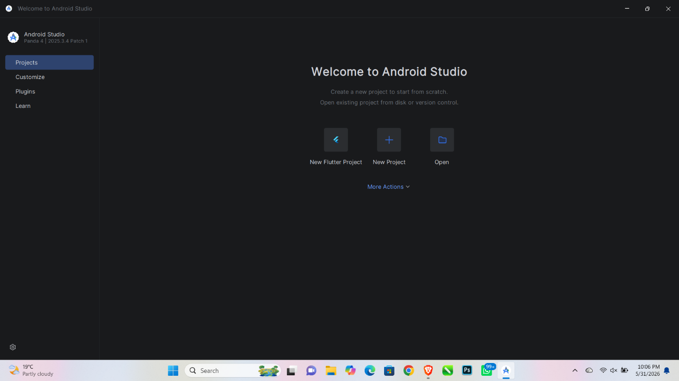

Screenshot: Android SDK Manager showing API 24 and API 34 installed
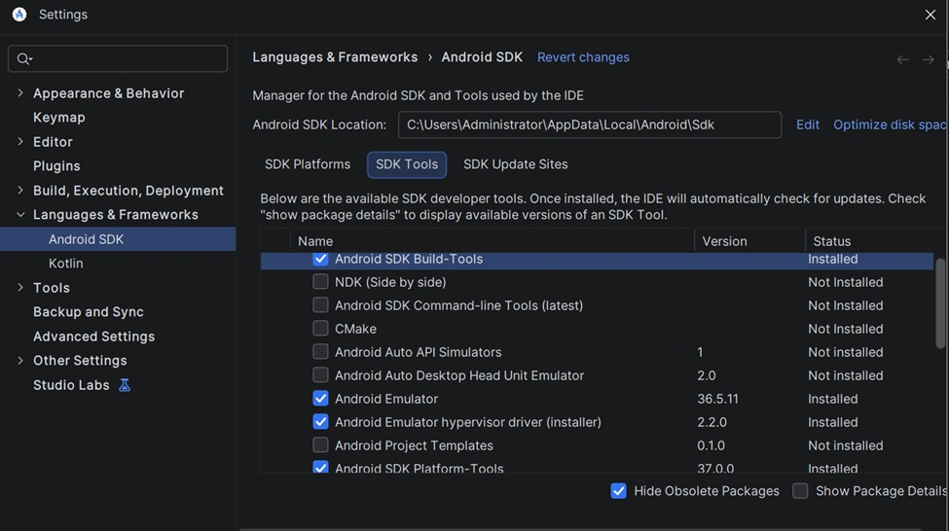

Screenshot: Android phone connected and visible in Android Studio device list
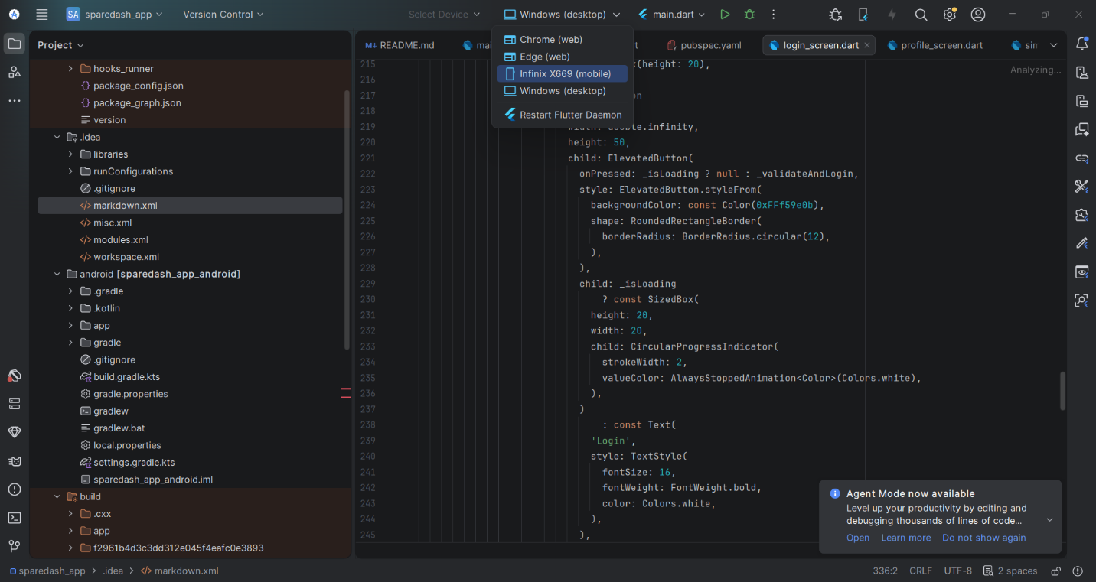

Screenshot: USB Debugging enabled in phone Developer Options
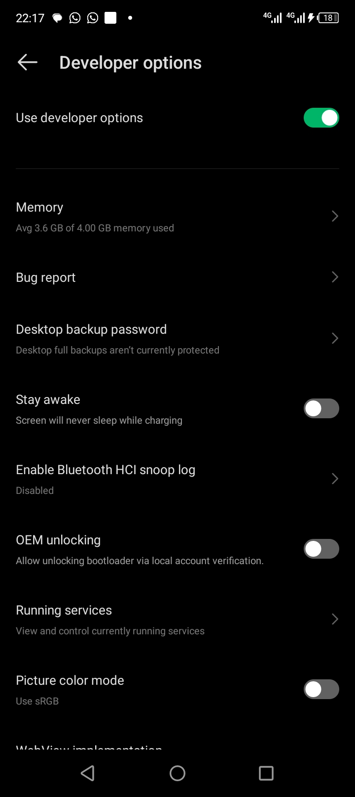

Screenshot: GitHub repository named SpareDash created
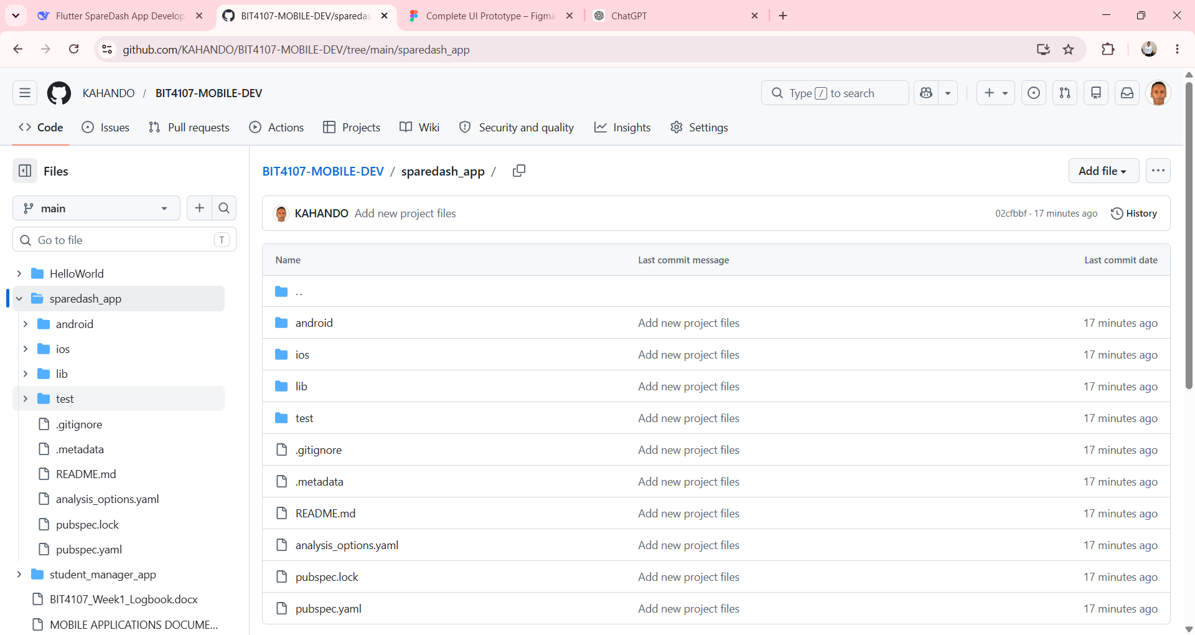

Tools / Software Used

Tool / Software | Version / Details | Purpose
Android Studio | Latest Stable 2024+ | Primary development IDE
Android SDK | API 24 and API 34 | Android platform libraries
Git | Latest version | Version control
GitHub | github.com | Remote repository hosting
Android Phone | USB connected | Real device for testing

Personal Reflection
Setting up Android Studio was straightforward. The most challenging part was configuring the Android SDK and ensuring the emulator ran without performance issues. I learned the difference between native and cross-platform development approaches. SpareDash will be built natively for Android using Kotlin for best performance.
WEEK 2: Mobile Development Environment

Practical Activities Undertaken
- Created new Android project: Name = SpareDash, Package = com.sparedash.app, Language = Kotlin, Min SDK = API 24.
- Confirmed Gradle sync completed successfully.
- Explored the generated project folder structure: java/, res/layout/, res/values/, AndroidManifest.xml.
- Added all required Gradle dependencies: Room, Navigation Component, ViewModel, LiveData, Glide, Coroutines, Material Design.
- Created package folders: data/, ui/, viewmodel/, utils/ inside com.sparedash.app.
- Defined app colour scheme in res/values/colors.xml.
- Configured AndroidManifest.xml: app name, theme, INTERNET permission.
- Ran the default Hello World app on the connected Android phone via USB.
- Made first GitHub commit: "Initial commit: SpareDash project setup".

Screenshots / Evidence
Screenshots Attached: Yes / No (circle one)

Screenshot: SpareDash project open in Android Studio showing folder structure
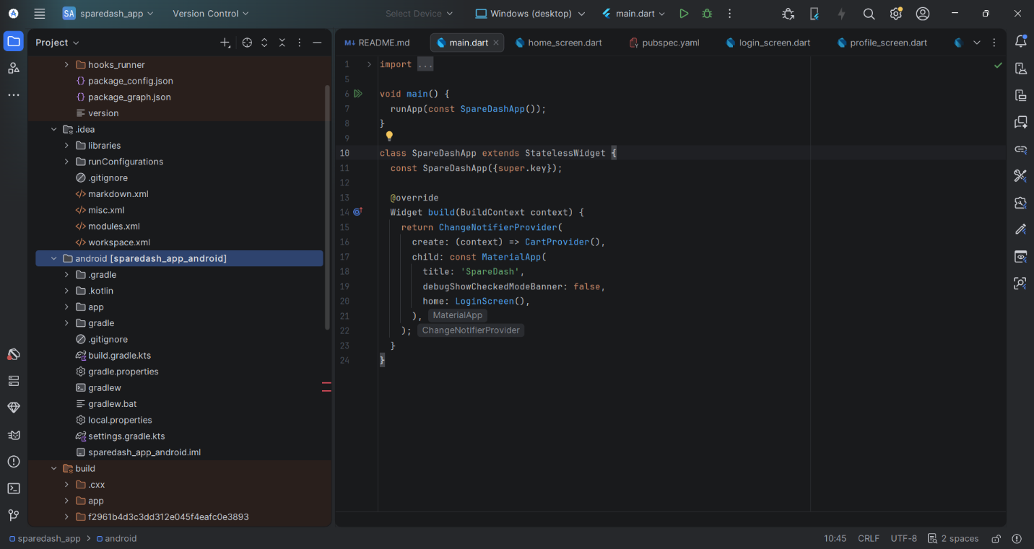

Screenshot: build.gradle.kts showing all dependencies added
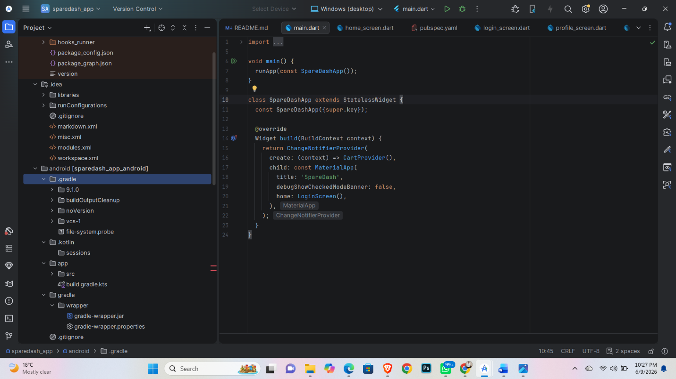

Screenshot: Default app running on real Android phone (USB)
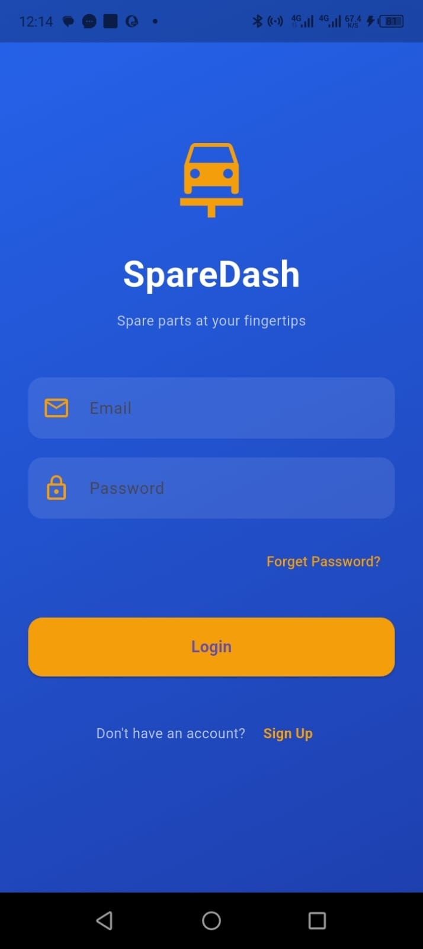

Screenshot: GitHub showing first commit
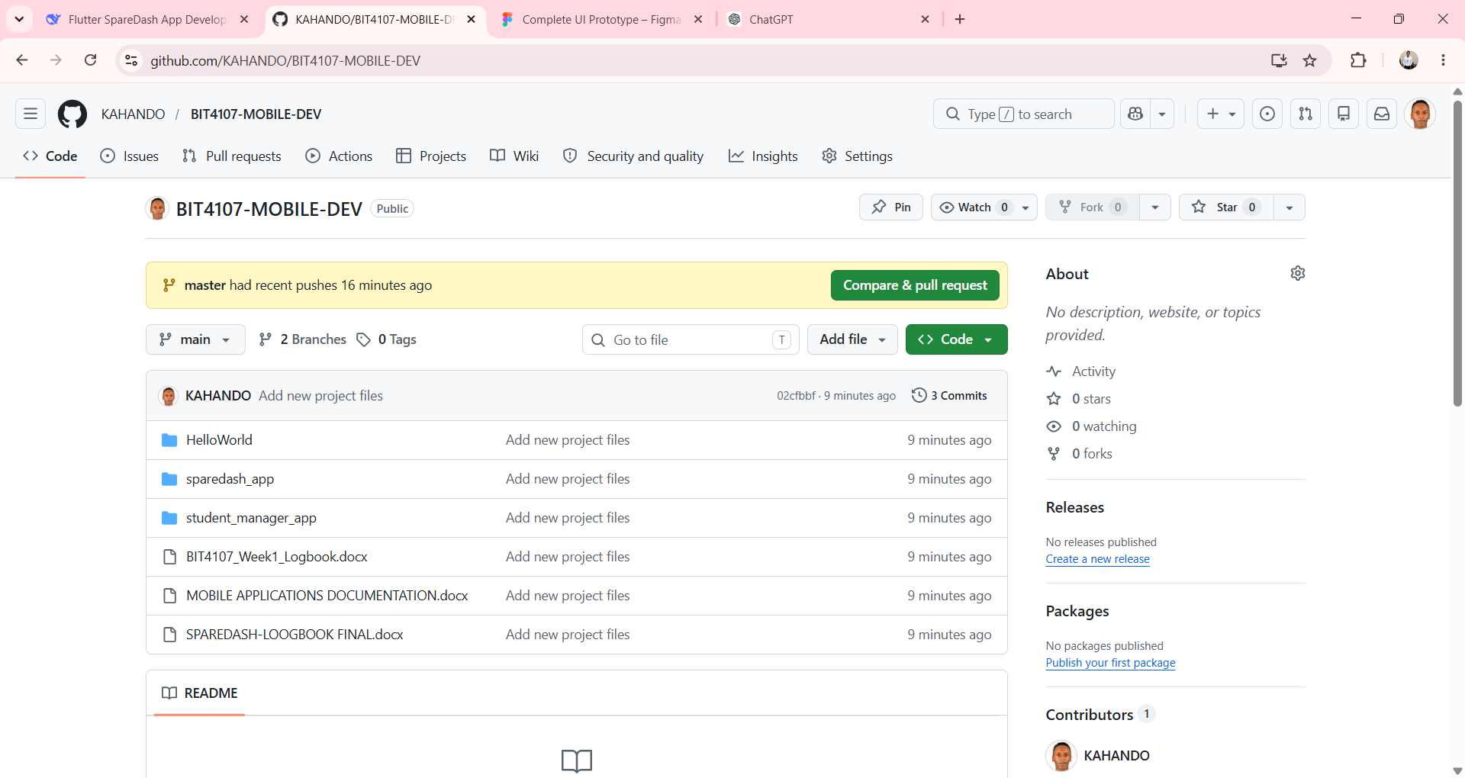

Tools / Software Used

Tool / Software | Version / Details | Purpose
Android Studio | Latest Stable | Project creation and coding
Gradle (Kotlin DSL) | build.gradle.kts | Build and dependency management
Material Design 3 | 1.11.0 | UI component library
Room Library | 2.6.1 | Local SQLite database
GitHub | github.com | Version control and portfolio
Android Phone via USB | — | Running app on real device

Personal Reflection
Adding all Gradle dependencies and syncing successfully gave me confidence. I struggled initially with Kotlin syntax compared to Java but practiced data classes and lambdas. Setting up the GitHub repository means my progress is tracked professionally. The emulator runs smoothly.

WEEK 3: User Interface Design

Practical Activities Undertaken
- Designed all 10 SpareDash wireframe screens in Figma: Splash, Login, Register, Home, Parts Catalogue, Part Details, Cart, Order Placement, Order Tracking, Admin Dashboard.
- Applied Material Design 3 principles across all screens.
- Created activity_splash.xml layout: app name centred on plain background.
- Created SplashActivity.kt: 2-second delay then navigates to LoginActivity.
- Created activity_login.xml: email field, password field, login button, register link.
- Created LoginActivity.kt: basic form validation (empty field check).
- Created activity_home.xml: RecyclerView grid for spare parts categories.
- Tested Splash Screen and Login Screen on real Android phone via USB.

Screenshots / Evidence
Screenshots Attached: Yes / No (circle one)

Screenshot: Figma workspace showing all SpareDash wireframe screens
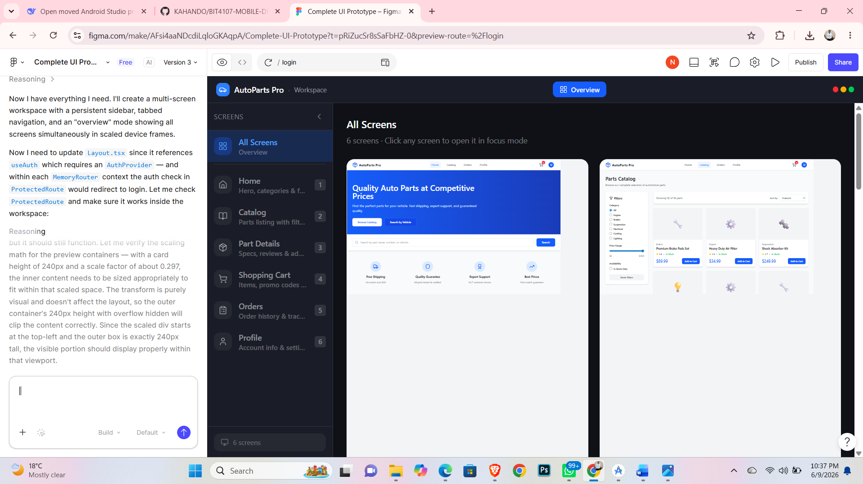

Screenshot: activity_splash.xml open in Android Studio Layout Editor
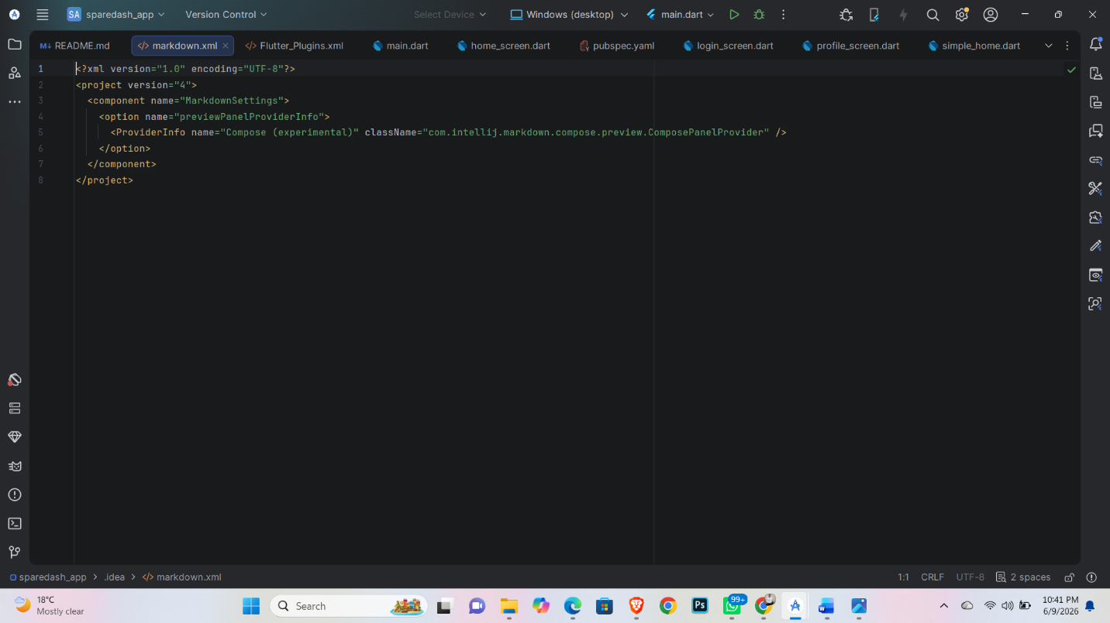

Screenshot: activity_login.xml open in Android Studio Layout Editor
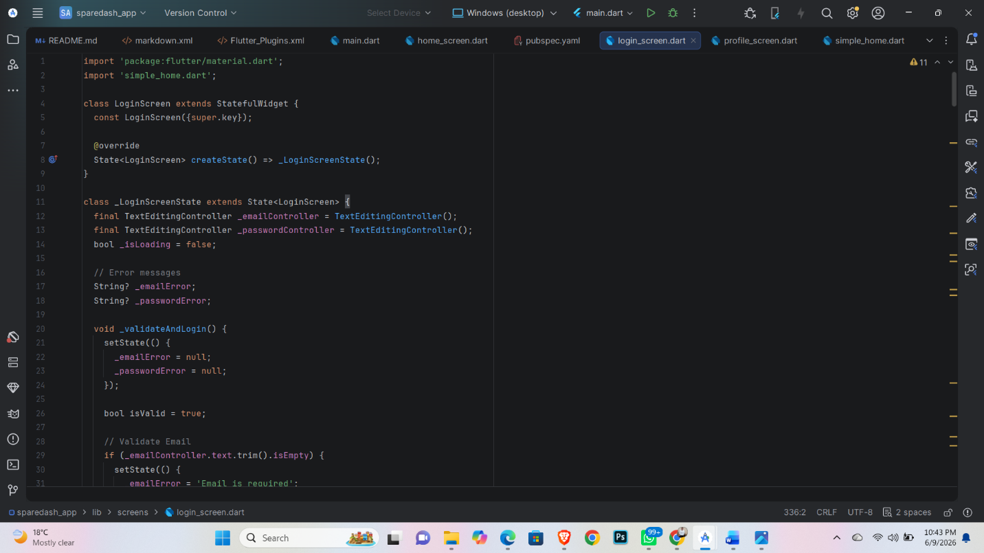

Screenshot: Splash Screen displayed on real Android phone
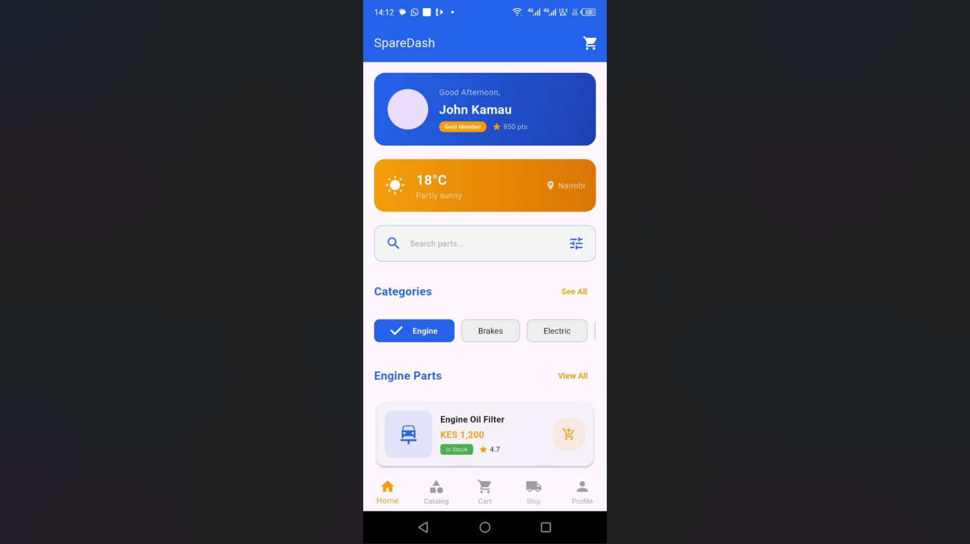

Screenshot: Login Screen displayed on real Android phone


Tools / Software Used

Tool / Software | Version / Details | Purpose
Figma | Web (free plan) | Wireframing and UI design
Android Studio Layout Editor | Built-in | XML layout design
Material Design 3 | Component library | UI design guidelines
ConstraintLayout | AndroidX | Flexible screen layouts
Android Phone via USB | — | Testing screens on real device

Personal Reflection
Designing all screens in Figma before coding saved significant time. I learned how Material Design 3 improves user experience. Converting Figma designs to Android XML was initially challenging but the Layout Editor preview helped greatly. The Splash Screen transition works perfectly.

WEEK 4: Event Handling and User Interaction

Practical Activities Undertaken
- Implemented LoginActivity.kt with full form validation: empty fields check and email format check.
- Created RegistrationActivity.kt with input fields: name, email, phone, password, confirm password.
- Added password visibility toggle using TextInputLayout from Material Design.
- Implemented click listeners for: Login button, Register link, and Back navigation.
- Added Toast messages to display validation error feedback to the user.
- Implemented Intent navigation: Login to Home, Login to Register.
- Tested all button interactions and form validation on real Android phone via USB.
- Committed changes to GitHub: "feat: Login and Registration screens with validation".

Screenshots / Evidence
Screenshots Attached: Yes / No (circle one)

Screenshot: LoginActivity.kt code showing click listener and validation logic
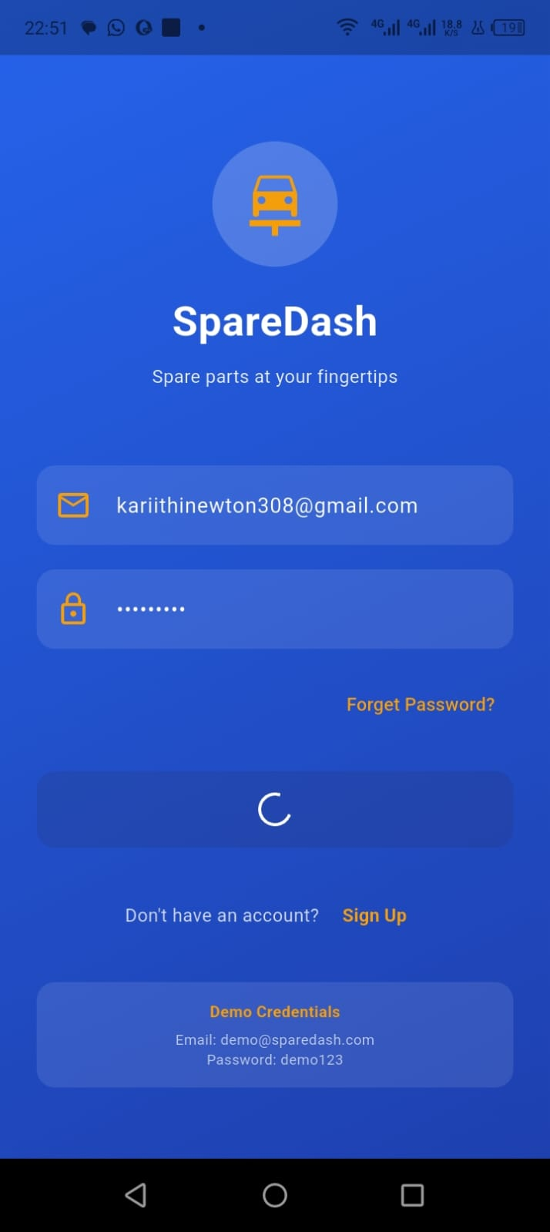

Screenshot: RegistrationActivity.kt code open in Android Studio
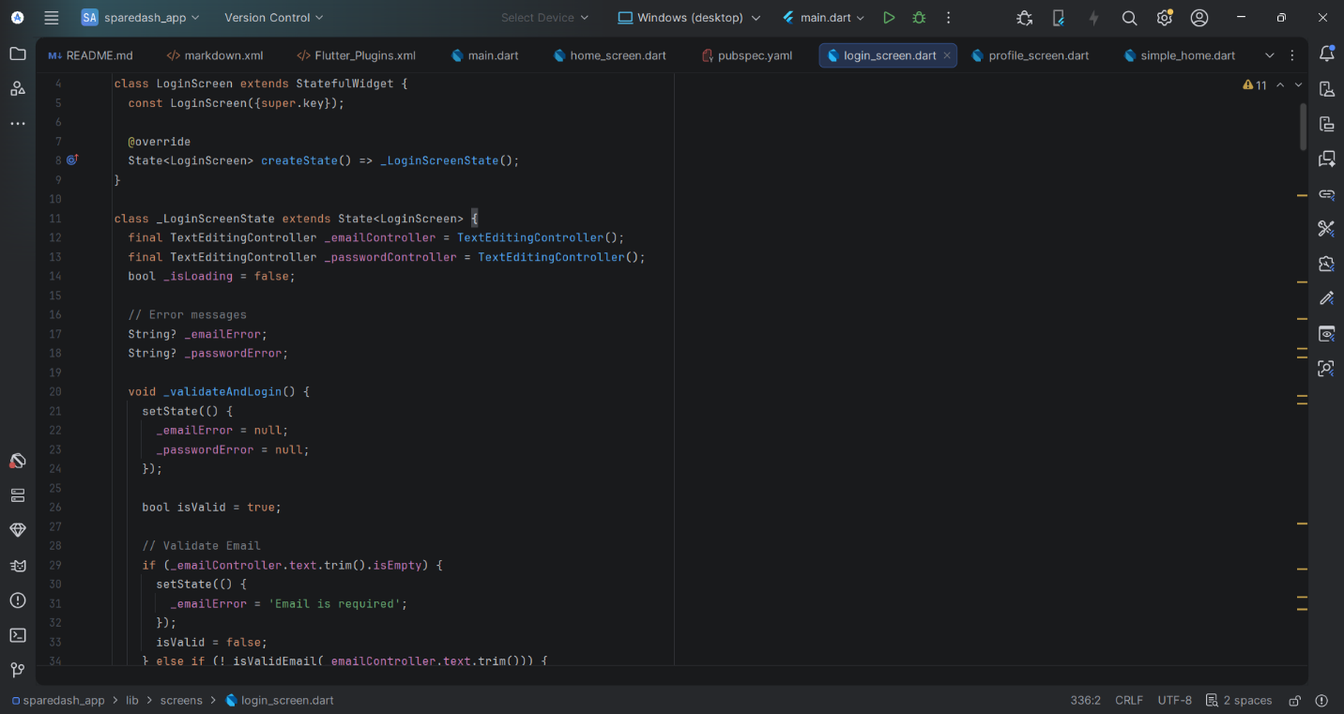

Screenshot: Login Screen on real phone showing validation toast for empty fields
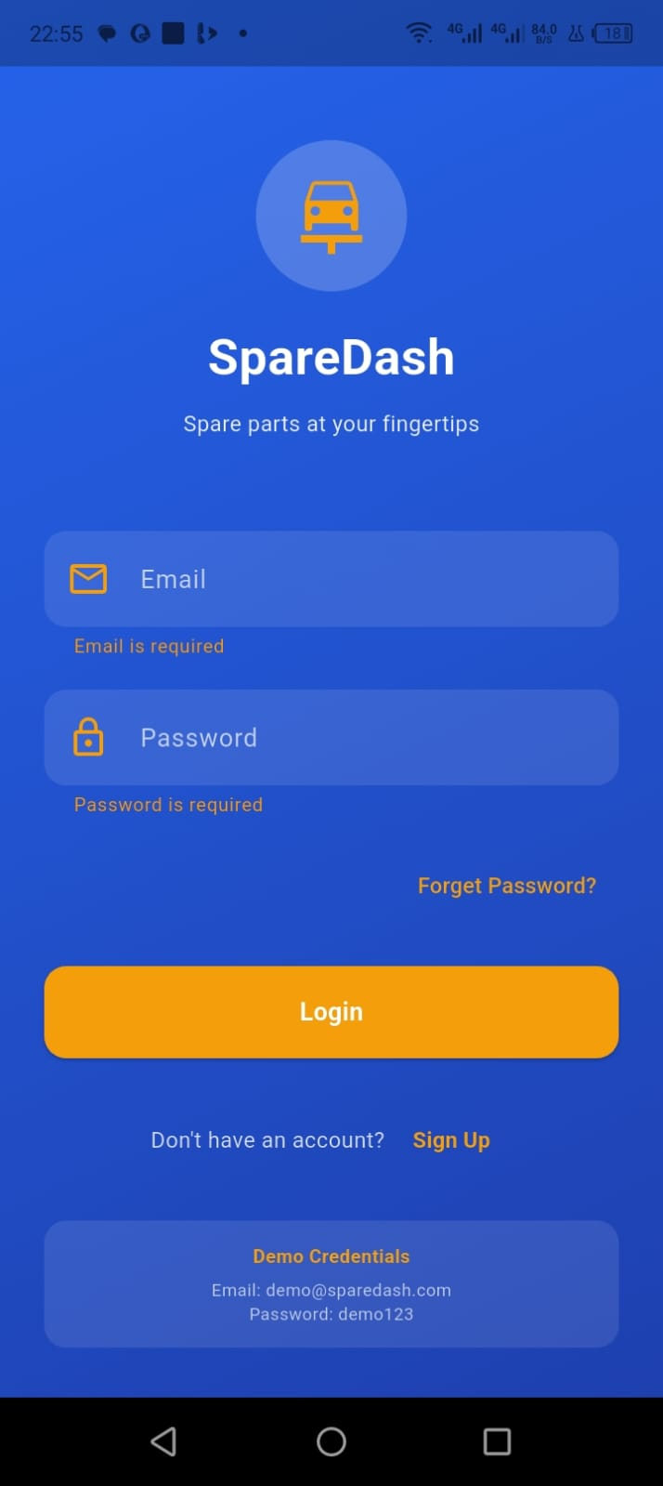

Screenshot: Registration Screen displayed on real Android phone
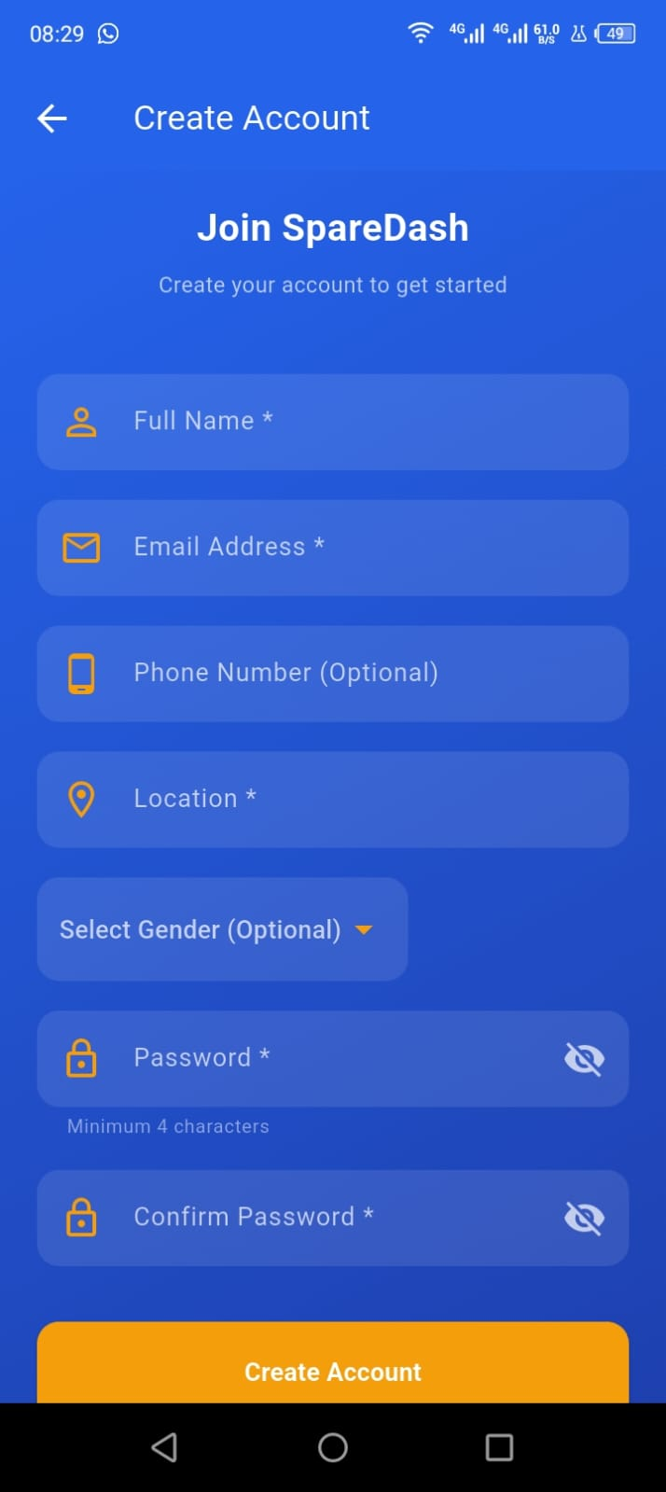

Screenshot: Successful navigation from Login to Home Screen on real phone
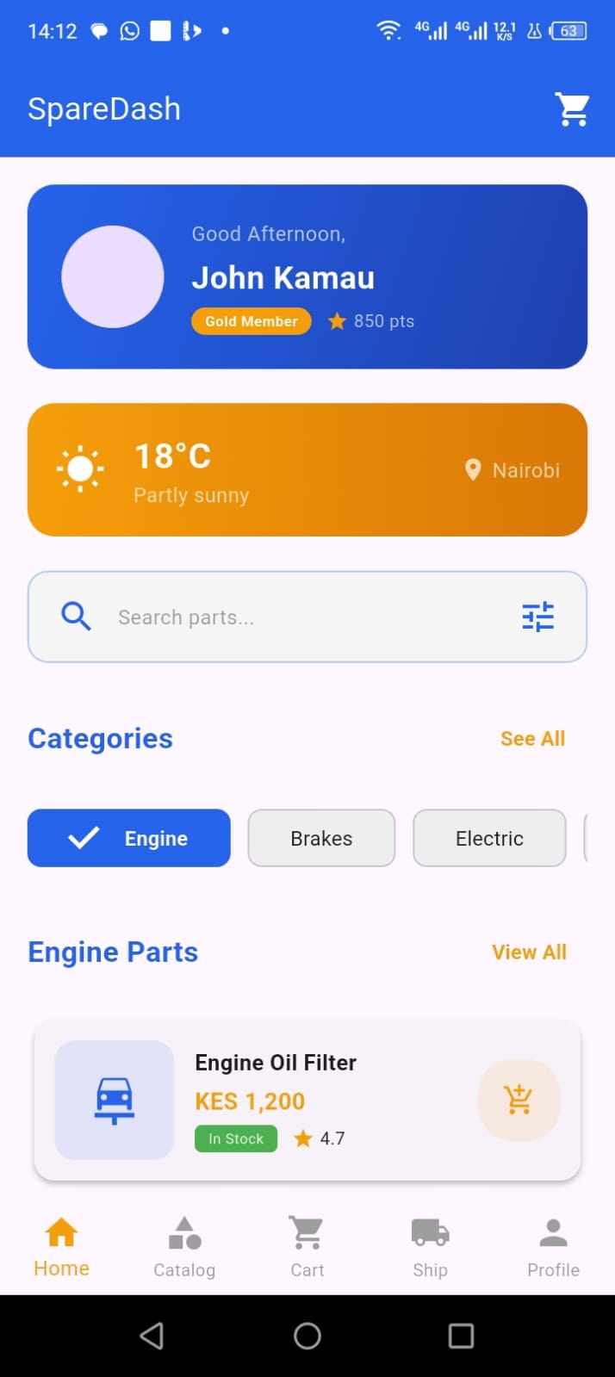

Tools / Software Used

Tool / Software | Version / Details | Purpose
Kotlin setOnClickListener | — | Button and link click handling
TextInputLayout | Material 1.11.0 | Password toggle and styled inputs
Toast | Android SDK | User feedback messages
Intent | Android SDK | Screen-to-screen navigation
Android Phone via USB | — | Testing interactions on real device

Personal Reflection
Implementing event handling in Kotlin felt natural once I understood lambdas. Form validation is critical for a real app — users expect immediate feedback. The password toggle feature makes the app feel professional. Registration and login flows now work end-to-end on the emulator.
WEEK 5: Data Management

Practical Activities Undertaken
- Created Room Database entity classes: Spare Part, Order, User.
- Created DAO interfaces: SparePartDao, OrderDao, UserDao with full CRUD operations.
- Built SpareDashDatabase.kt as a singleton using the companion object pattern.
- Created Repository classes to abstract database access from ViewModels.
- Built SparePartViewModel.kt connected to LiveData for reactive UI updates.
- Populated database with 20 sample spare parts across 6 categories.
- Tested database inserts and query operations using Android Studio Debugger and Logcat.
- Verified data displays correctly on Home Screen on real Android phone.
- Committed to GitHub: "feat: Room database entities, DAO, ViewModel".

Screenshots / Evidence
Screenshots Attached: Yes / No (circle one)

Screenshot: Home Screen on real phone showing spare parts loaded from Room database
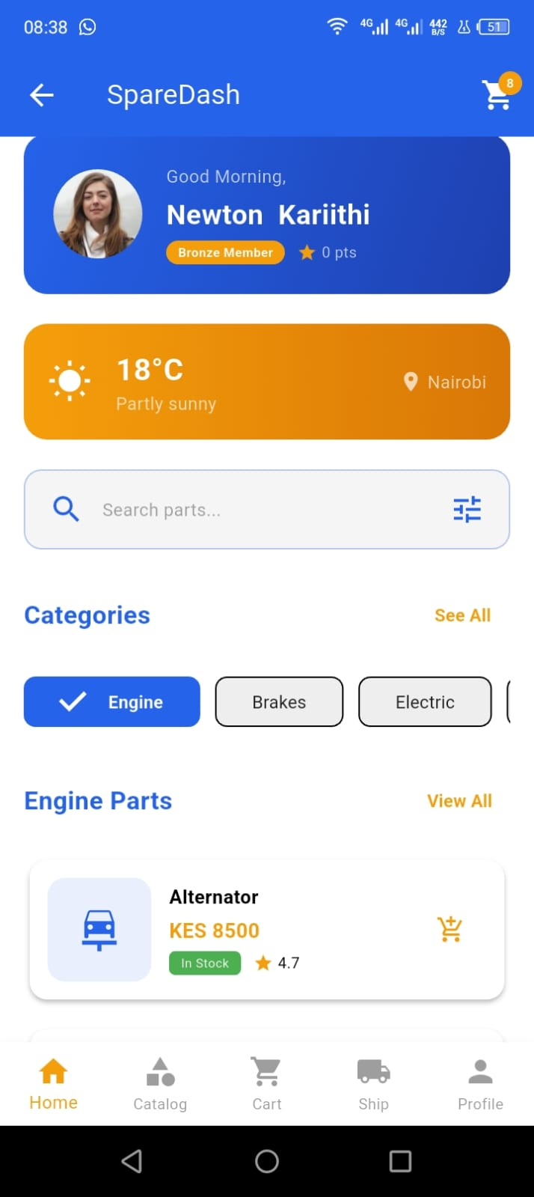

Tools / Software Used

Tool / Software | Version / Details | Purpose
Room Persistence Library | 2.6.1 | SQLite database abstraction
LiveData | Lifecycle 2.7.0 | Reactive data observation
ViewModel | Lifecycle 2.7.0 | UI state management
Coroutines | 1.7.3 | Background database operations
Android Studio Logcat | Built-in | Debugging database operations
Android Phone via USB | — | Viewing real data on device

Personal Reflection
Room makes SQLite much simpler than raw SQL. Understanding the View Model and Live Data pattern was challenging initially but I now see how it prevents memory leaks. Seeing real spare parts data display on screen from my own database was very satisfying.

WEEK 6: Networking and APIs

Practical Activities Undertaken
- Created Firebase project named SpareDash at console.firebase.google.com.
- Added Android app to Firebase with package name com.sparedash.app.
- Downloaded google-services. json and placed inside the app/ folder.
- Added Firebase BOM, Authentication, Firestore, and Messaging dependencies to Gradle.
- Replaced local authentication with Firebase email and password Authentication.
- Implemented Firebase user registration and login in Kotlin.
- Synced spare parts data to Firestore cloud database.
- Added INTERNET permission to AndroidManifest.xml.
- Tested registration and login on real Android phone via USB.

Screenshots / Evidence
Screenshots Attached: Yes / No (circle one)

Screenshot: Firebase Console showing SpareDash project created
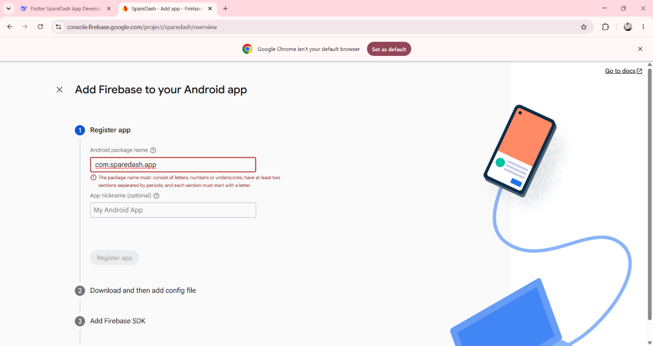

Screenshot: google-services.json visible inside app/ folder in Android Studio
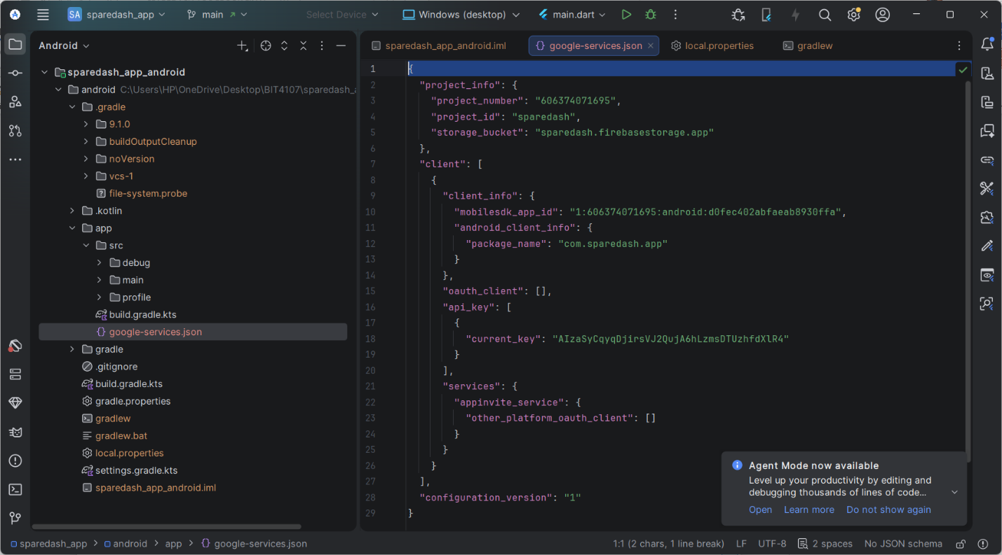

Tools / Software Used

Tool / Software | Version / Details | Purpose
Firebase BOM | 32.7.0 | Firebase dependency management
Firebase Authentication | firebase-auth-ktx | User login and registration
Cloud Firestore | firebase-firestore-ktx | Cloud database
Firebase Messaging | firebase-messaging-ktx | Push notifications
Android Phone via USB | — | Testing Firebase auth on device

Personal Reflection
Integrating Firebase was easier than expected. The hardest part was correctly placing google-services. json. Seeing my registered user appear instantly in Firebase console was impressive. Cloud sync means SpareDash data persists across devices — a huge improvement over local-only storage.

